Student Name: Nguyen Anh Vu

Student ID: 103806007

Lab 07

Task 1: Create a new table cars used for a car dealership

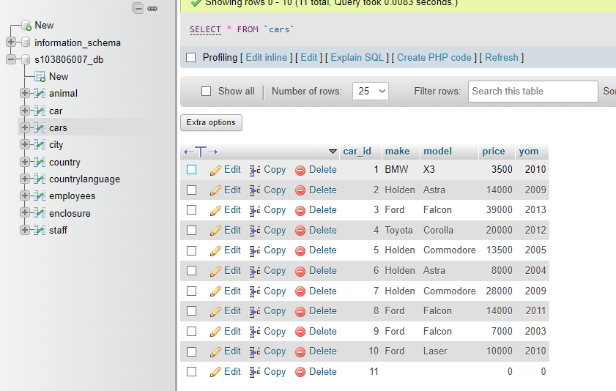

Query used:

CREATE TABLE cars (

car_id int(11) NOT NULL AUTO_INCREMENT,

make varchar(25),

model varchar(40),

price float,

yom int(11),

PRIMARY KEY (car_id)

);

To insert into table we use query:

INSERT INTO cars (car_id, make, model, price, yom) VALUES

(NULL, ‘BMW’, ‘X3’, ‘3500’, ‘2010’);

Task 2: Querying the table

1. Return all record

Query: “SELECT * FROM cars;”

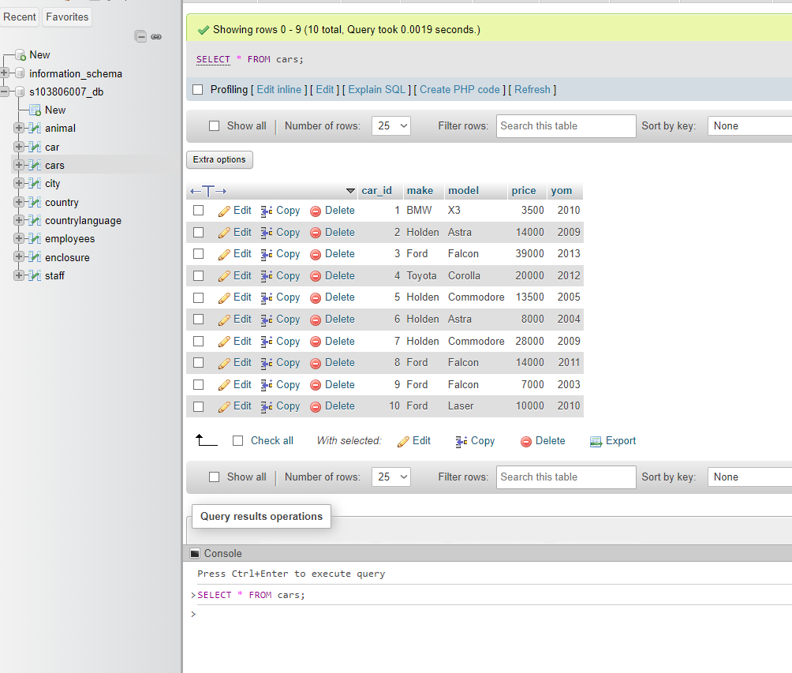

1. Make, model, and price, sorted by make and model

Query: “SELECT make, model, price FROM cars ORDER BY make, model;”

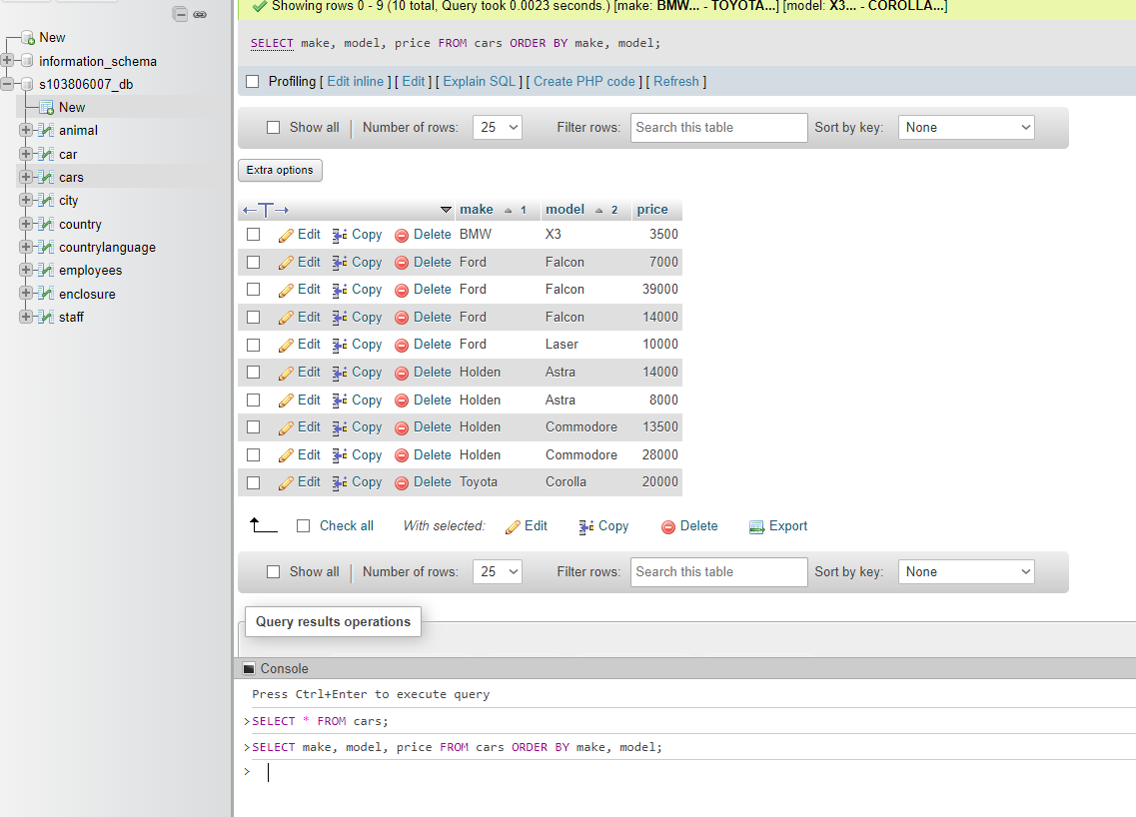

1. The make and model of the cars which cost $20,000.00 or more

Query: “SELECT make, model FROM cars WHERE price >= 20000;”

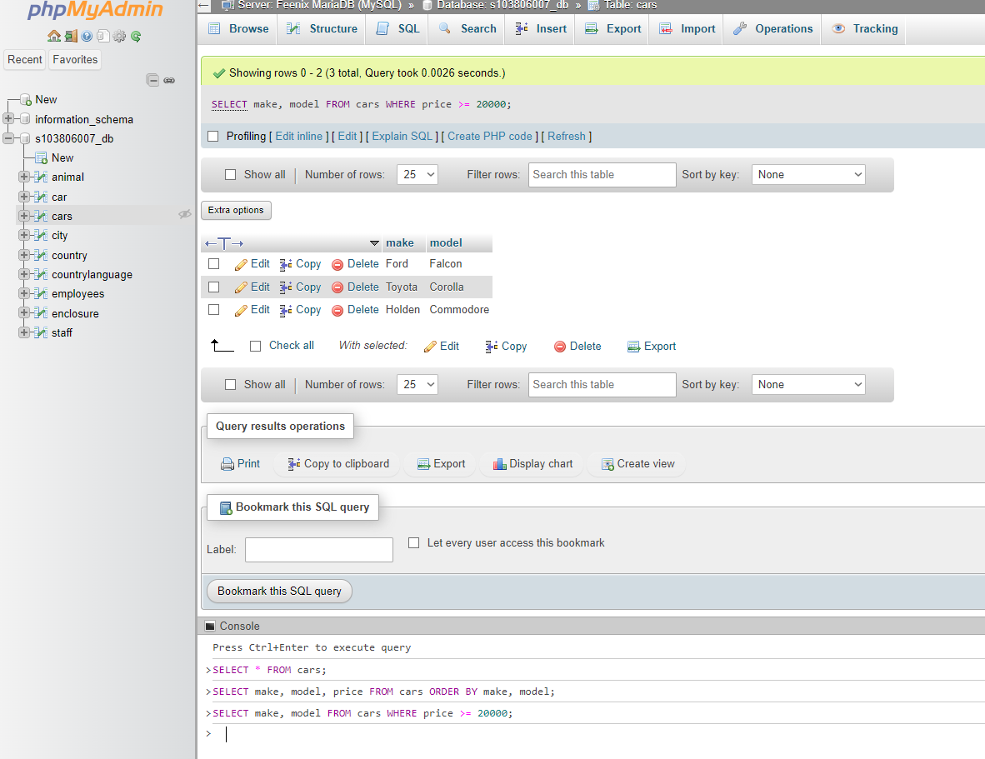

1. The make and model of the cars which cost below $15,000.00

Query: “SELECT make, model FROM cars WHERE price < 15000;”

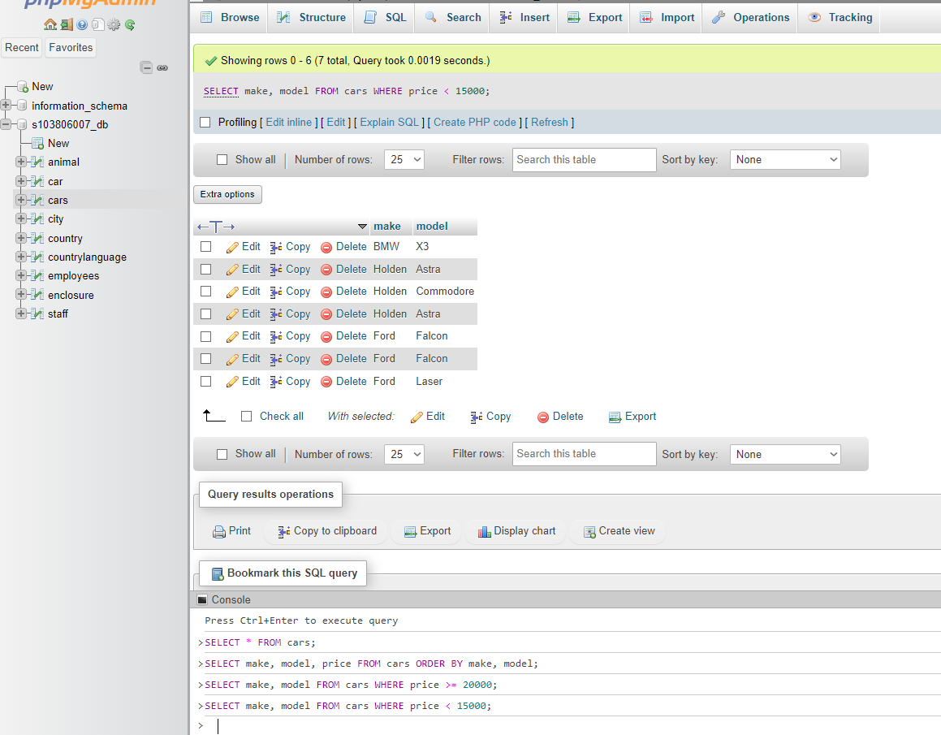

1. The average prices of cars for similar make

Query: “SELECT make,AVG(price) AS AveragePrice FROM cars GROUP BY make;”

